Economic Growth Rankings & Monte-Carlo Simulation — 1-Page Summary
Economic Science adaptation of R ranking + simulation techniques (vectors, lists, functions, apply, Monte-Carlo)
Problem Statement
Policy analysts and economics students need a transparent way to rank a set of focus economies by growth performance, attach rich attributes (inflation, region, debt), and then quantify how uncertain those rankings are. Analytic rank probabilities become intractable once growth is stochastic and we care about joint events (e.g., all three LatAm economies finishing in the top half). A Monte-Carlo approach in base R supplies the required probabilities, sensitivity analysis, and bootstrap confidence intervals.
Solution Strategy
1. Store focus countries in a vector and their indicators in a named list. 2. Implement find_rank with a classic loop (and idiomatic match/which alternates). 3. Apply the function with lapply/sapply. 4. Treat baseline growth rates as means of normal distributions; draw many growth paths; re-rank every path. 5. Compute mean ranks, P(rank = 1), joint probabilities, sensitivity to volatility and policy shocks, and bootstrap CIs for mean rank. The same engine supports scenario comparison for teaching or policy work.
Solution (key results)
Country | Baseline g% | Mean rank | P(rank=1) | Static rank
CostaRica | 4.1 | ~1.4 | ~0.57 | 4
Chile | 2.4 | ~2.1 | ~0.25 | 5
Mexico | 2.0 | ~2.5 | ~0.18 | 7
Workflow + example growth & rank probability plots:
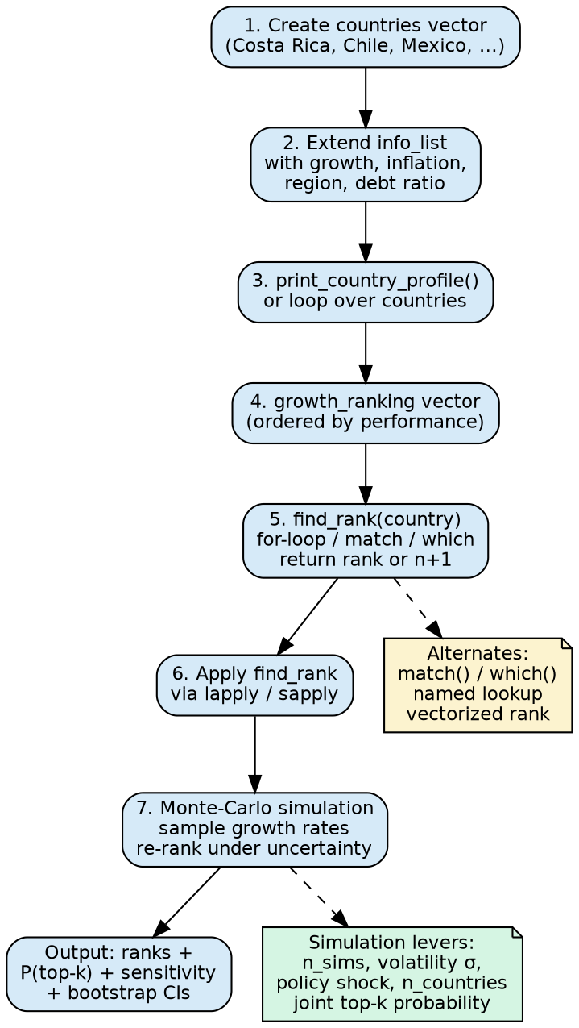
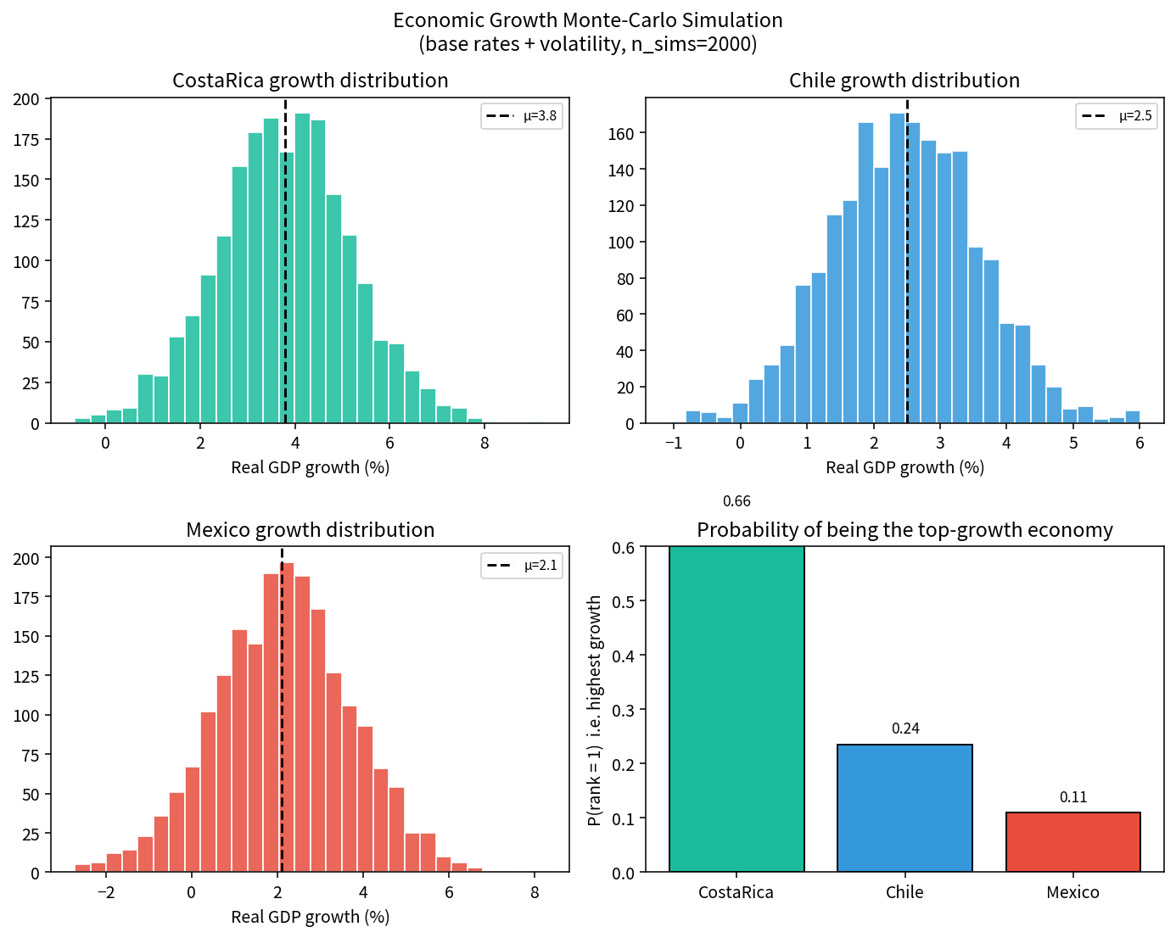
Key Takeaways
• Named lists + ranking functions give a clean, extensible representation of country economic profiles.
• Monte-Carlo re-ranking converts baseline growth + volatility into transparent rank probabilities and joint-event estimates.
• Sensitivity to σ and to policy shocks is immediate—ideal for classroom or policy scenario work.
• The same simulation engine supplies bootstrap confidence intervals for any rank-based statistic without analytic formulas.
• Audience adaptation: executives receive the P(rank=1) table; analysts receive the full growth matrices and code; students start with the loop version of find_rank.
Files: Practice_Skeleton.ipynb • Solution.ipynb • 1Page_Report.docx • flowchart.png • simulation_plots.png • Extended_Project.zip

